Townfield Primary School
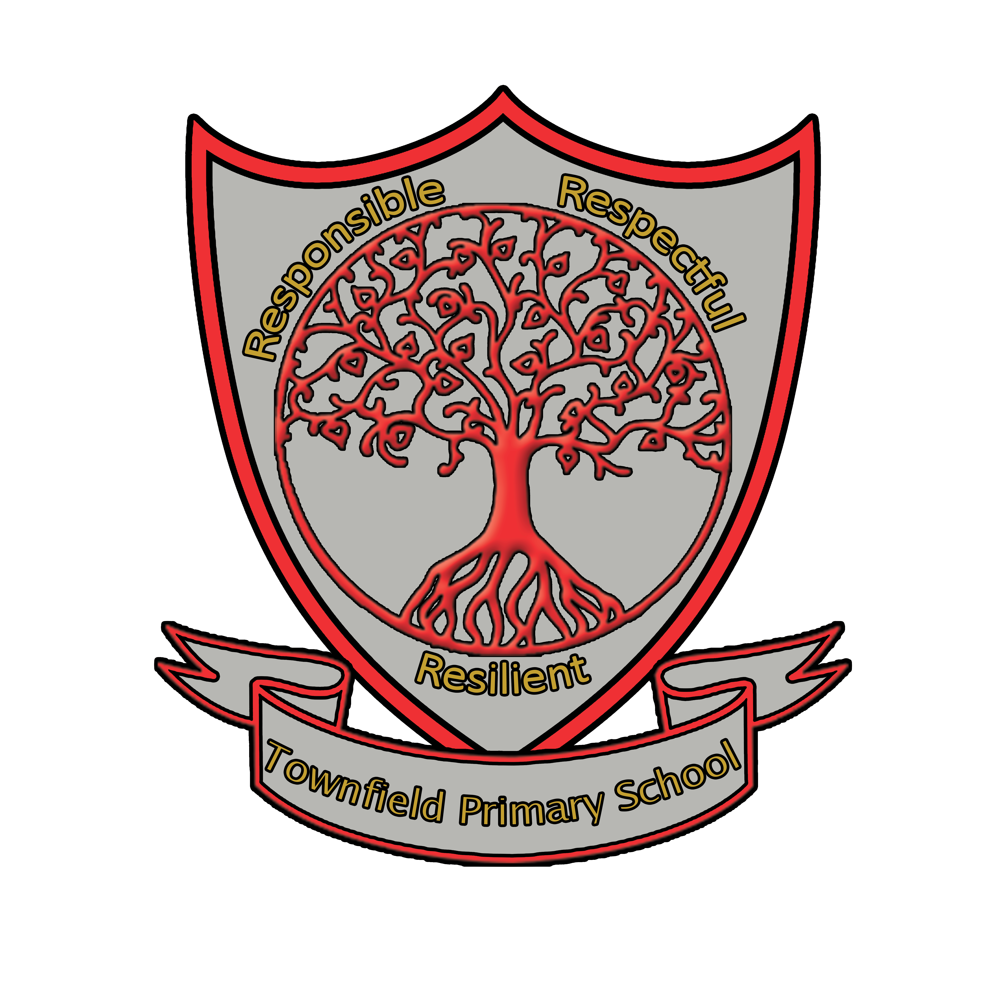
Vision for Physical Education (P.E.) and Sport

This vision was adopted by the Governing Body Spring 2020
This vision is due for review Spring 2021
Respectful Resilient Responsible
At Townfield Primary School we follow the National Curriculum and have made some enhancements such as inviting in specialist tennis and rugby coaches as well as providing opportunities to develop PE during woodland learning sessions. Our vision for Physical Education and sport is that every child including those who have SEN and/or disabilities and those who are disadvantaged has the opportunity to take part in physical activity on a regular basis and become more physically confident and competent. We hope that through all the sporting opportunities and physical activity we offer, the children will develop a love and passion for sport and continue this into their later lives.

We aim to provide the children with at least 2 hours of fun, exciting and active PE lessons every week. To keep the children healthy and active, they have at least 30 minutes of physical activity a day and are educated on a healthy, balanced diet and lifestyle. The pupils gain knowledge about agility, balance and coordination, and gain mastery in basic movements including running, jumping, throwing and catching. They begin to apply these in a range of activities, participate in team games, developing simple tactics for attacking and defending and perform dances using simple movement patterns.

At Townfield, we also strive to give as many children as possible the opportunity to compete in a variety of competitions, during school time or by representing the school at local events. We hope that in doing so the children will develop greater confidence, team work and learn to win or lose with grace and sportsmanship.

It is also of paramount importance that we create sporting leaders during the children's time at Townfield. We aim to offer lots of children the opportunity to lead sporting activities, organise games and events and learn to lead by example. By emphasising leadership, we hope the children learn the importance of communication, organisation, team work, resilience, perseverance and a respect for rules.

We have built our own scheme of work which builds in complexity so that pupils can build their skills and knowledge. Kknowledge and skills are constantly revisited and refreshed to ensure that they become embedded. To aid understanding subject specific vocabulary is taught explicitly within every lesson. We have created end points for each topic and milestones for the end of each year to show what pupils should know and can do. As the children move to the next year group, the next teacher then knows where to start.

Pupils come from a mixed urban area of Wirral. We have selected significant sports role-models to study, male and female, who share the context of the pupils. To build pupils’ cultural capital, they also study the work of both Olympians and Para-Olympians who are nationally important. Our core values; resilience, respect and responsibility are continually developed through all PE learning experiences.

